Spread Locator: Part A — Theoretical Foundation

1. What is a Statistical Distribution?
Definition
A statistical (probability) distribution describes how the values of a random variable are spread out, showing which values are more or less likely to occur. It is typically represented using a Probability Mass Function (PMF) for discrete variables or a Probability Density Function (PDF) for continuous variables, and can be summarized visually with histograms, PDF curves, or CDF curves. Distributions are the foundation for statistical inference, hypothesis testing, and predictive modeling, since they describe the underlying data-generating process of a dataset such as customer transaction amounts.
Formula
For discrete X: P(X = x) via a PMF.
For continuous X: P(a < X < b) = ∫[a to b] f(x) dx via a PDF.
Explanation
Distributions are usually summarized by shape (symmetric, skewed, heavy-tailed), central tendency (mean, median, mode) and spread (variance, standard deviation). Knowing the correct distribution for a dataset allows analysts to estimate probabilities, detect outliers, and choose the right statistical tests or models.
Example
Customer transaction amounts on an e-commerce platform, when plotted as a histogram, form a right-skewed shape — most purchases are small-to-moderate, with a few very large ones. This shape is a statistical distribution (in this case, close to Log-Normal).
Real-life Application
Distributions underlie almost every data-driven decision: insurance companies use them to price risk, banks use them to model default rates, and e-commerce platforms use them to forecast demand and detect fraudulent transactions.
Diagram
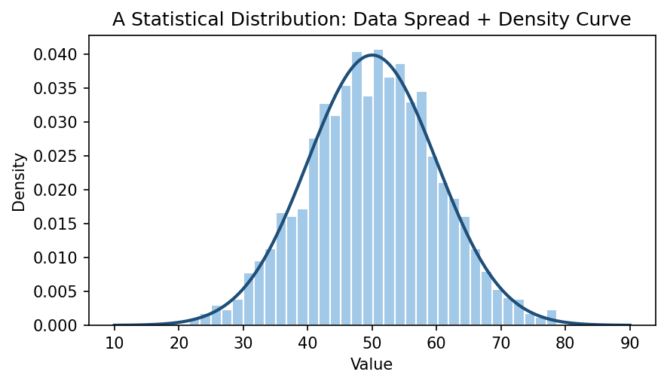
Histogram of sample data with its fitted probability density curve.

2. What is a Q-Q Plot and Why is it Used?
Definition
A Quantile-Quantile (Q-Q) Plot is a graphical technique used to compare the quantiles of an observed dataset against the quantiles of a theoretical distribution (most commonly the Normal distribution). Each point on the plot represents a quantile pair; if the data follows the theoretical distribution, the points fall approximately along a straight 45-degree reference line.
Formula
Plot points: (Theoretical Quantile_i , Sample Quantile_i) for i = 1...n,
where quantiles are computed from the sorted data and the inverse CDF of the reference distribution.
Explanation
If the data matches the theoretical distribution, the points lie approximately on the 45-degree reference line. An S-shaped curve indicates skewness; points curving away at the ends indicate heavier or lighter tails than the reference distribution. Q-Q plots are used to visually verify normality assumptions before applying parametric statistical tests (t-tests, ANOVA, linear regression).
Example
Plotting transaction amounts on a Normal Q-Q plot shows the points curving sharply upward at the right end — this confirms the data is right-skewed and not normally distributed, prompting a log transform before further analysis.
Real-life Application
Q-Q plots are used in finance to check if asset returns are normally distributed (important for risk models like Value-at-Risk), and in quality control/manufacturing to verify that a process's output follows the expected distribution.
Diagram
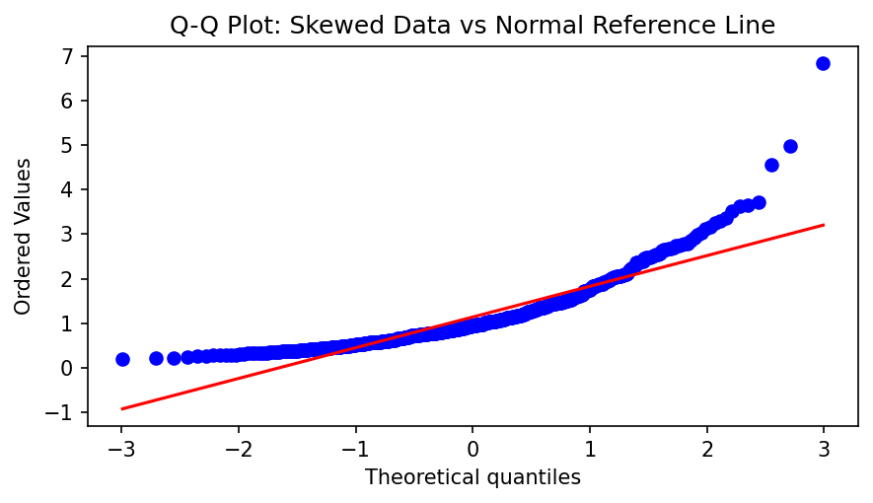
Q-Q plot of right-skewed data against a Normal reference line.

3. Difference between Discrete and Continuous Distributions

Feature | Discrete Distribution | Continuos Distribution
Random variable | Takes countable values | Takes infinitely many values within a range
Examples | Number of students, number of defective items, dice outcomes | Height, weight, temperature, time
Probability function | Probability Mass Function (PMF) | Probability Density Function (PDF)
Probability at a single value | Can be greater than 0 (e.g., (P(X=3)=0.2)) | Always 0 (e.g., (P(X=3)=0))
Total probability | Sum of probabilities equals 1 | Area under the PDF equals 1
Probability calculation | By summing probabilities | By integrating (finding the area under the curve)
Graph | Separate bars | Smooth curve

Diagram
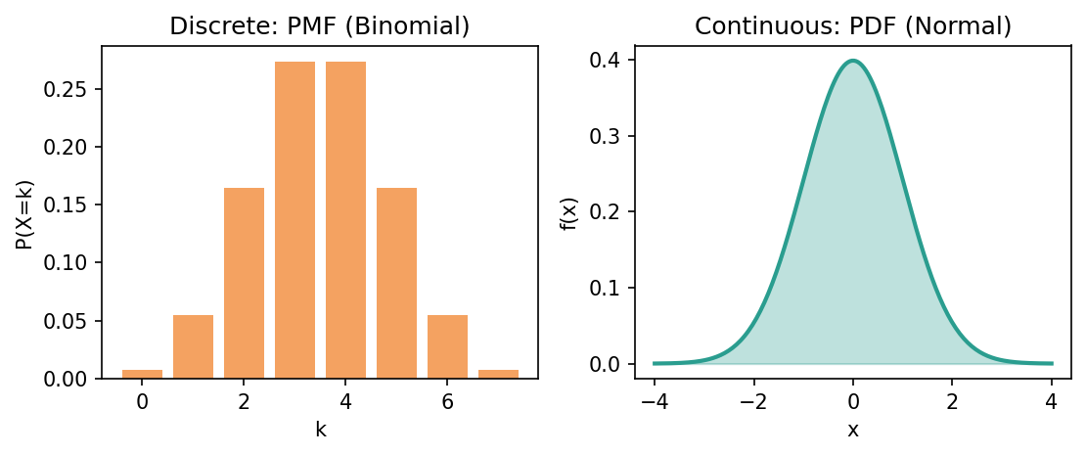
PMF (discrete, bars) vs PDF (continuous, smooth curve).

4. Bernoulli Distribution
Definition
The Bernoulli distribution models a single trial with exactly two possible outcomes: success (1) with probability p, and failure (0) with probability (1 − p).
Formula
P(X = 1) = p, P(X = 0) = 1 − p
Mean E[X] = p
Variance Var(X) = p(1 − p)
Explanation
It is the simplest possible discrete distribution and represents one 'yes/no' trial. It is the foundational building block for the Binomial distribution, which counts successes over many Bernoulli trials.
Example
Whether a single transaction is 'Success' or 'Fail' is a Bernoulli trial. If 92% of transactions succeed historically, p = 0.92, so P(a random transaction fails) = 0.08.
Real-life Application
Bernoulli trials model any single binary event: whether a coin flip is heads, whether a patient responds to treatment, whether a user clicks an ad, or whether a manufactured part passes quality inspection.
Diagram
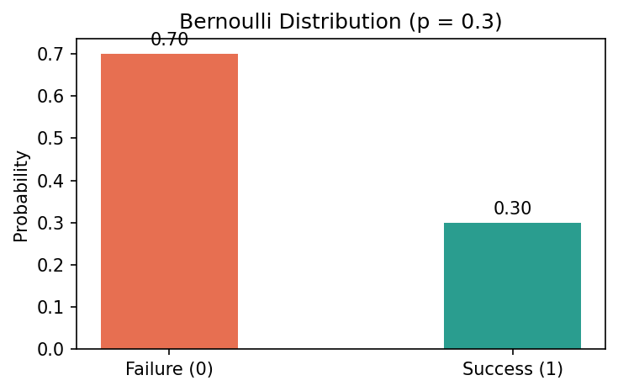
Bernoulli distribution with p = 0.3 (probability of each outcome).

5. Binomial Distribution
Definition
The Binomial distribution models the number of successes in n independent, identical Bernoulli trials, each with the same success probability p.
Formula
P(X = k) = C(n, k) · p^k · (1 − p)^(n − k), for k = 0, 1, ..., n
Mean E[X] = n·p
Variance Var(X) = n·p(1 − p)
Explanation
The Binomial distribution answers: 'out of n attempts, how many succeed?' It assumes each trial is independent and has the same success probability. As n grows large, the Binomial distribution approaches a Normal shape (by the Central Limit Theorem).
Example
If a customer makes n = 5 transactions in a week and each has a 92% chance of success (p = 0.92), the number of successful transactions that week follows Binomial(5, 0.92); we can compute, for example, the probability all 5 succeed.
Real-life Application
Binomial models are used in quality control (number of defective items in a sample batch), medicine (number of patients responding to a drug out of a trial group), and marketing (number of customers who convert out of those shown an ad).
Diagram
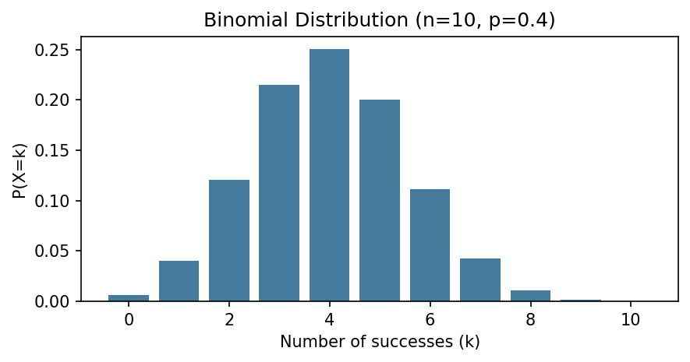
Binomial PMF for n = 10 trials, p = 0.4.

6. Log-Normal Distribution
Definition
A random variable X follows a Log-Normal distribution if ln(X) (its natural logarithm) is normally distributed. Log-Normal variables are always positive and right-skewed.
Formula
f(x) = 1 / (x·σ·√(2π)) · exp(−(ln x − μ)² / (2σ²)), for x > 0
Mean = exp(μ + σ²/2)
Explanation
Log-Normal distributions naturally arise when a quantity results from multiplying many independent positive random factors (rather than adding them, which gives a Normal distribution). This produces a characteristic long right tail: most values are small-to-moderate, with a smaller number of much larger values.
Example
Customer transaction amounts in this project follow this shape: most purchases cluster around ₹500–2000, while a small number of large purchases (₹20,000+) stretch the right tail — the natural log of these amounts is close to normally distributed.
Real-life Application
Log-Normal distributions are widely used to model income, stock prices, city populations, and biological measurements — any quantity that grows multiplicatively and cannot go negative.
Diagram
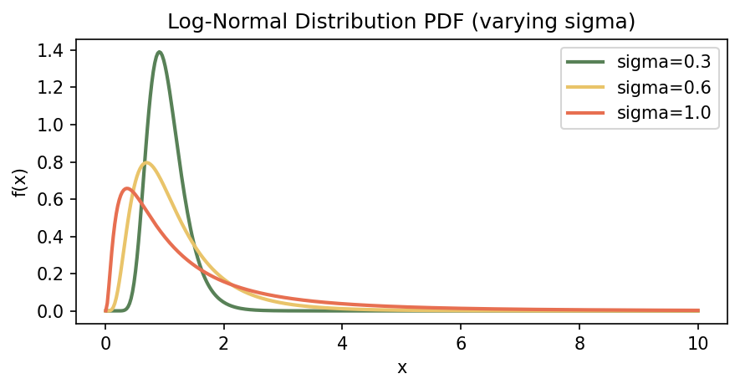
Log-Normal PDF shape for different sigma (spread) values.

7. Power Law Distribution
Definition
A Power Law distribution has the form P(X = x) ∝ x^(−α), where probability decreases polynomially (not exponentially) as x grows — producing very heavy tails where extreme values are far more common than under a Normal or even Log-Normal model.
Formula
P(X = x) = C · x^(−α), for x ≥ x_min, where α > 1 is the tail exponent and C is a normalizing constant.
Explanation
The defining property of a power law is scale invariance: the shape of the distribution looks the same at any magnitude when viewed on a log-log plot (a straight line). This means rare, extreme events (outliers) occur with far higher probability than a Normal distribution would ever predict — this is the mathematical basis of 'fat tails' and 'black swan' events.
Example
In this project, the extreme upper tail of transaction amounts (a small number of very large, 'whale' purchases) behaves like a power law — plotting the top 10% of amounts on a log-log scale shows an approximately straight line.
Real-life Application
Power laws describe wealth and income inequality (Pareto's 80/20 principle), city population sizes, word frequency in language (Zipf's law), earthquake magnitudes, and social network follower counts.
Diagram
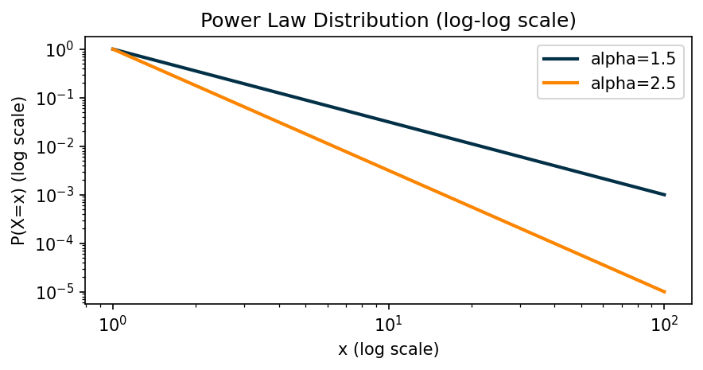
Power Law distributions for two tail exponents, on log-log axes.

8. Box-Cox Transformation
Definition
The Box-Cox transform is a family of power transformations that converts non-normal, heteroscedastic (unequal-variance) data into a shape that more closely approximates a Normal distribution, stabilizing variance in the process.
Formula
y(λ) = (x^λ − 1) / λ, if λ ≠ 0
y(λ) = ln(x), if λ = 0
(x must be strictly positive; λ is estimated via maximum likelihood)
Explanation
The parameter λ controls the strength and type of the transform: λ = 1 leaves data unchanged, λ = 0 is equivalent to a log transform, and negative λ applies a reciprocal-power transform. The optimal λ is chosen to maximize the normality of the transformed data, which is essential before applying methods (like linear regression or t-tests) that assume normally distributed, equal-variance data.
Example
Applying Box-Cox to skewed transaction amounts yields an optimal λ close to 0 — confirming that a simple log transform is nearly ideal for normalizing this dataset and reducing its skewness.
Real-life Application
Box-Cox transforms are used in regression modeling (to satisfy normality/homoscedasticity assumptions), econometrics (transforming GDP or price data), and manufacturing process control (stabilizing variance of measurement data before control-chart analysis).
Diagram
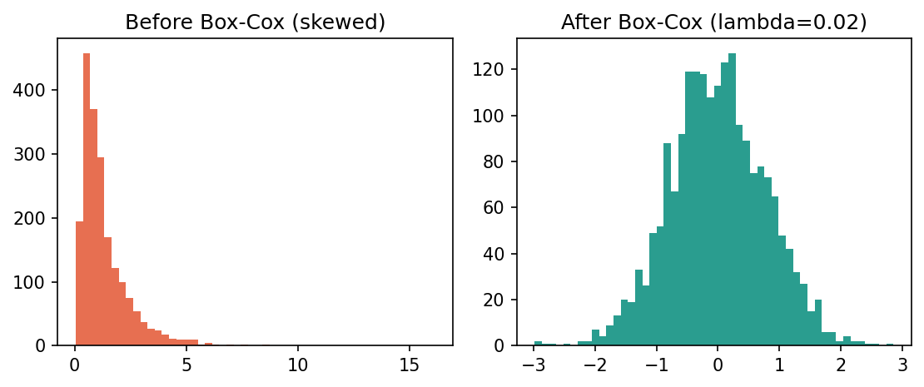
Skewed data before Box-Cox (left) and normalized after (right).

9. Poisson Distribution (with Example)
Definition
The Poisson distribution models the number of times a discrete event occurs within a fixed interval of time or space, assuming events happen independently and at a constant average rate (λ).
Formula
P(X = k) = (e^(−λ) · λ^k) / k!, for k = 0, 1, 2, ...
Mean = λ, Variance = λ
Explanation
Poisson is appropriate when events are rare relative to the total number of opportunities, occur independently of each other, and happen at a roughly constant average rate. A defining property is that its mean equals its variance — a useful diagnostic check when deciding if a Poisson model fits real count data.
Example
Example: Suppose an e-commerce platform averages λ = 150 transactions per day. The probability of receiving exactly 160 transactions tomorrow is P(X = 160) = (e^(−150) · 150^160) / 160!, which can be computed directly using the Poisson PMF — useful for setting server-load and staffing thresholds with a known probability of being exceeded.
Real-life Application
Poisson models are used for call-center call volume, website traffic spikes, number of accidents at an intersection per month, and number of defects per unit area in manufacturing.
Diagram
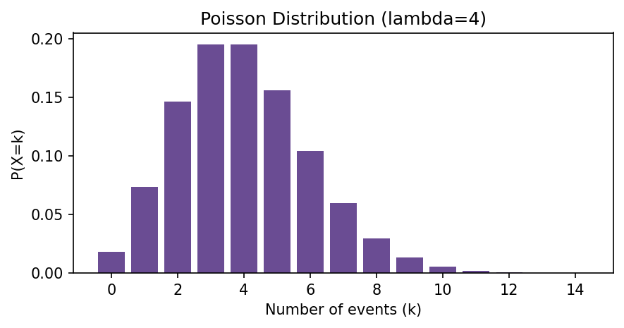
Poisson PMF for an average rate of λ = 4 events.

10. Z-score Probability
Definition
A Z-score standardizes a data point by measuring how many standard deviations it lies above or below the mean of a distribution, allowing the standard Normal distribution's known probabilities to be used.
Formula
Z = (X − μ) / σ
P(X > x) ≈ 1 − Φ(Z), where Φ is the standard Normal CDF
Explanation
Once a raw value is converted into a Z-score, it can be looked up against the standard Normal table (mean 0, standard deviation 1) to estimate the probability of observing a value that extreme or more extreme. This approach assumes the underlying data is approximately Normal — applying it to skewed data (like raw transaction amounts) can give a misleading probability estimate.
Example
If the mean transaction amount is ₹1840 with a standard deviation of ₹3377, a ₹5000 transaction has Z = (5000 − 1840) / 3377 ≈ 0.94. Using the Normal table gives P(X > 5000) ≈ 17%, but because the actual data is right-skewed rather than Normal, this understates the true (empirical) probability.
Real-life Application
Z-scores are used in academic grading (standardized test percentiles), quality control (flagging measurements beyond ±3σ as out-of-spec), and finance (identifying unusually large price moves relative to historical volatility).
Diagram
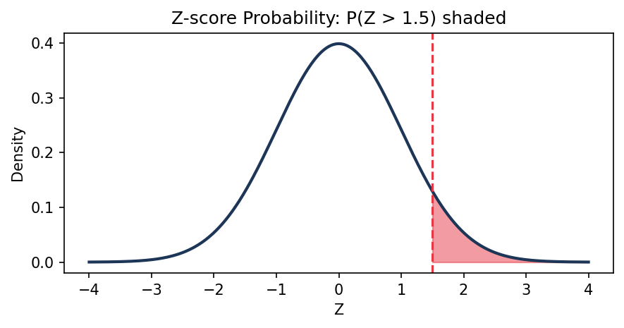
Standard Normal curve with the probability P(Z > 1.5) shaded.

11. Difference between PDF and CDF

Feature | PDF | CDF
Full form | Probability Density Function | Cumulative Distribution Function
Purpose | Describes how probability is distributed over values | Gives the probability that a random variable is less than or equal to a value
Notation | (f(x)) | (F(x))
Formula | (f(x)) | (F(x)=P(X\le x)=\int_{-\infty}^{x} f(t),dt) (for continuous variables)
Probability at a point | (P(X=x)=0) for continuous variables | Gives accumulated probability up to (x)
Range | (f(x)\ge 0), can be greater than 1 | Always between 0 and 1
Graph | Shows peaks where values are more likely | Always non-decreasing, starts at 0 and ends at 1

Diagram
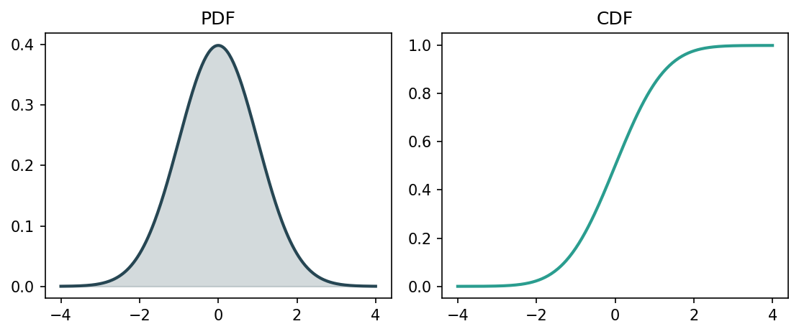
PDF (left) shows density shape; CDF (right) shows cumulative probability.

